Amazon India Sales Analysis
Apparel & accessories seller · 31 Mar – 29 Jun 2022 · Findings and recommendations

1. Executive summary
This report analyses 128,017 order lines from the Amazon.in sales extract (31 March – 29 June 2022, 91 days) across the six objectives set out in the brief. After excluding cancelled orders, the business sold ₹71.3M of merchandise (≈₹7.13 crore) across 103,063 orders and 110,327 units.
₹71.3M  Net sales (ex-cancelled) | 103,063  Active orders | ₹709  Avg. order value | 14.1%  Cancellation rate
-14%  Revenue / day, Apr→Jun | -19%  Orders / day, Apr→Jun | 56%  Top 5 states' share | +4.8 pts  Easy Ship cancel gap

What the data says
- Sales are drifting down, driven by order volume. Revenue per day fell from ₹868K in April to ₹747K in June (-14%) and orders per day fell -19%. The cause is fewer orders: revenue per order actually rose slightly (₹668 in April to ₹706 in June).
- T-shirts are the engine and the problem. T-shirts are 50% of revenue but their daily revenue fell 25% from April to June, accounting for most of the overall decline. Blazers moved the other way (+39%).
- Sizes M–XL carry half of volume (50%), and 27% of units are XXL or larger. The size curve differs by category: shirts have real 4XL–6XL demand (3.2% of shirt units); T-shirts, blazers and trousers essentially have none.
- Merchant-fulfilled (Easy Ship) orders cancel far more often: 17.4% vs 12.6% for Amazon-fulfilled, in every month and every major category. Merchant fulfilment handles 29% of revenue.
- 94% of orders are single-item. The 5.8% of orders that contain more than one item are worth ₹1,408 on average (vs ₹665 for single-item orders) and generate 11.5% of revenue.
- Demand is concentrated. Five states give 56% of revenue (Maharashtra, Karnataka, Telangana, Uttar Pradesh, Tamil Nadu); six cities (Bengaluru, Hyderabad, Mumbai, New Delhi, Chennai, Pune) give 35%. South India is 40% of sales.

Top recommendations
- Stabilise T-shirts first (pricing, promotions, ad spend and stock availability review) – this is the largest single lever.
- Cut Easy Ship cancellations by moving fast-selling sizes/categories to Amazon fulfilment or fixing pick-up and stock-sync issues.
- Rebuild the size curve per category instead of one curve for the whole catalogue.
- Bundle to lift order value: shirt + trouser and blazer + shirt offers with a spend threshold.
- Defend the core metros and fix regional leaks (Kerala, Andhra Pradesh, Bihar cancellations/returns).
- Capture better data (customer ID, SKU, cancellation reason, delivery date) so the next analysis can measure repeat purchase and delivery speed.

2. Data and method
The source is the Amazon sales report CSV (128,976 rows, 21 columns). Revenue is the order-line Amount in Indian rupees (all non-missing values are INR). Each row is one order line, so an order can have several rows.
Step | Treatment | Effect
Dates | Two text formats were mixed (mm-dd-yy and mm-dd-yyyy); both parsed month-first. Result is a continuous 91-day series with no gaps. | 31 Mar – 29 Jun 2022
Duplicates | Removed rows identical on every field except the running index. | 959 rows (0.7%); ≈₹0.4M of revenue
Cancelled orders | Excluded from revenue, units and order counts; analysed separately as cancellation rate. Most carry no amount. | 18,044 lines (14.1%)
Missing / zero amounts | Non-cancelled lines with no recorded amount count as ₹0 revenue; they stay in order counts. | 2,562 lines (2.3%)
Returns | Status “Returned/Returning to Seller” or “Rejected by Buyer”. Shown as a rate and a revenue at risk; not deducted from headline sales. | 2,100 lines; ₹1.38M
Partial days | 31 Mar is a one-day stub (171 raw rows) and 29 Jun looks like a partial day (revenue 37% below the previous 7-day average, 624 lines vs about 900–1,100 on prior days). Both are excluded from per-day rates but kept in totals. | 29 Jun = ₹409K
Clean-ups | “Blazzer” renamed Blazer; state names standardised (69 raw spellings → 36 states/UTs); 32 lines have no ship-to location. | –

Limits to keep in mind. The extract has no customer ID, SKU, cancellation reason or delivery date. Customer segmentation is therefore order-level (behaviour within an order), not lifetime behaviour, and repeat-purchase rates, delivery speed and cancellation causes cannot be measured. Recorded returns appear only on Merchant-fulfilled orders, so return rates cannot be compared across fulfilment methods. Three months of data cannot separate seasonality from trend.

3. Sales overview
Net sales exclude cancelled lines. 7-day average smooths day-of-week noise.
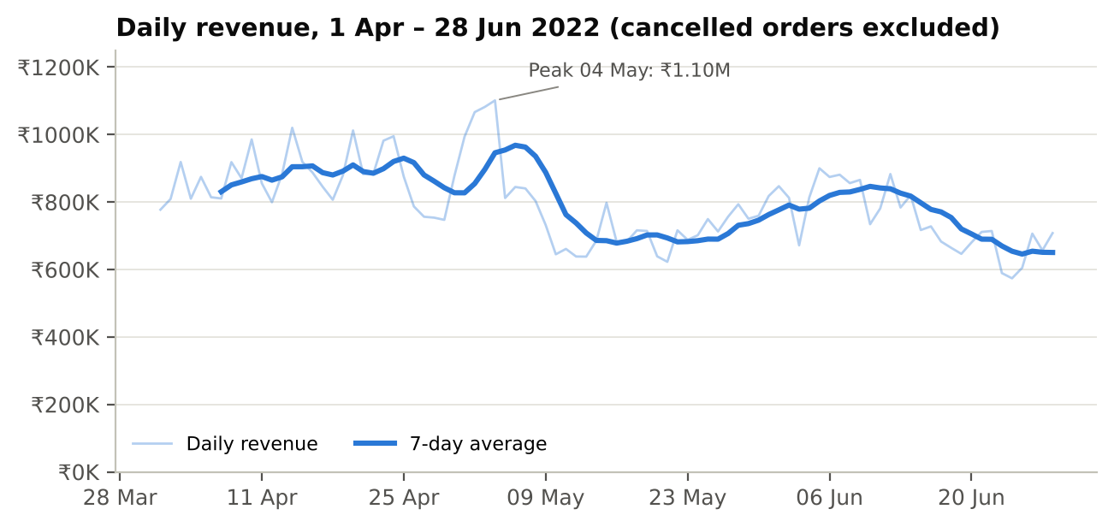
Month | Net sales | Revenue / day | Orders | Orders / day | Units
April | ₹26.0M | ₹868K | 39,002 | 1,300 | 41,750
May | ₹23.8M | ₹769K | 33,737 | 1,088 | 36,080
June (1–28) | ₹20.9M | ₹747K | 29,609 | 1,057 | 31,721

June is shown for 1–28 June so that per-day rates are like-for-like.
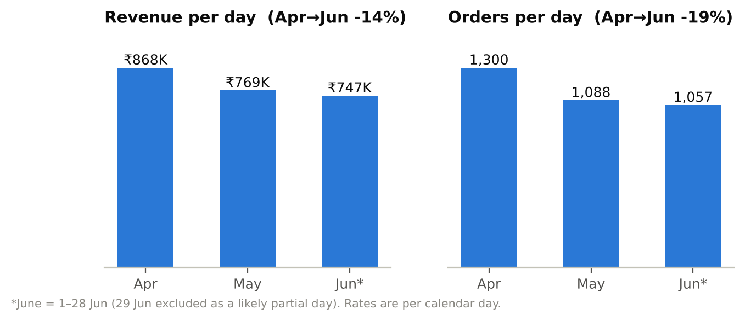

Findings
- Level shifted down in May, then drifted. The first half of the window (1 Apr – 15 May) averaged ₹853K per day versus ₹737K afterwards (-14%). Revenue per order rose from ₹668 in April to ₹706 in June, so the decline comes from fewer orders, not smaller baskets.
- One spike, then a trough. Revenue peaked on 04 May (₹1.10M) with 2–4 May all above ₹1.06M, then fell to about ₹0.65M by 10 May, well below the April average. This pattern is typical of demand pulled forward by an event or promotion; the extract does not say what happened, so confirm with the promotion calendar.
- Weak weekly pattern. Sunday is the strongest day (₹842K/day) and Friday the weakest (₹753K/day), a spread of only 12%. Day-of-week timing is not a useful lever here.
- Cancellations are steady, 14.4% in April, 13.8% in May and 13.9% in June of order lines, so the sales decline is not a cancellation problem. Cancelled lines with a recorded amount average ₹643; at that value, the cancelled lines represent roughly ₹11.6M of lost demand (an estimate, since most cancelled lines have no amount).

4. Product analysis
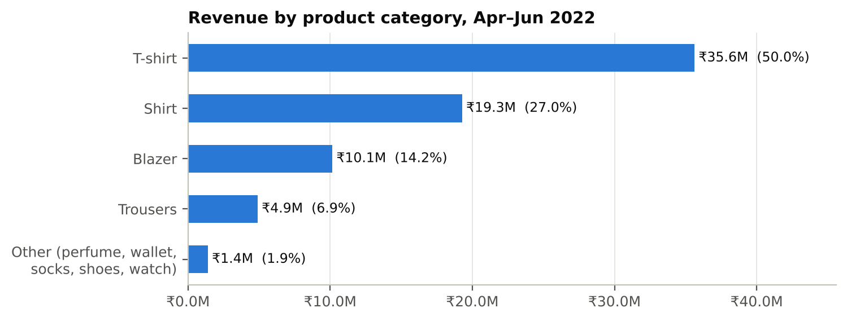
Category | Net sales | Share | Units | Avg. line value | Cancel rate | Return rate*
T-shirt | ₹35.6M | 50.0% | 42,887 | ₹854 | 14.5% | 2.0%
Shirt | ₹19.3M | 27.0% | 42,431 | ₹466 | 14.4% | 1.8%
Blazer | ₹10.1M | 14.2% | 13,327 | ₹777 | 13.7% | 2.6%
Trousers | ₹4.9M | 6.9% | 9,334 | ₹535 | 12.0% | 1.4%
Other (5 categories) | ₹1.4M | 1.9% | 2,348 | – | – | –

*Return rate counts recorded returns (Merchant-fulfilled only) as a share of all non-cancelled lines in the category. Avg. line value excludes lines with no amount.
- Four categories make up 98.1% of sales. T-shirts bring 50% of revenue from 39% of units because the average T-shirt line (₹854) is worth about 1.8× the average shirt line (₹466).
- Quantities are almost always one. 99.6% of lines are for exactly one unit, so bulk buying is negligible; growth has to come from more orders or more items per order.
- Perfume, wallets, socks, shoes and watches are immaterial (1.9% of sales combined). They are either a distraction or untested; decide deliberately whether to invest or prune.
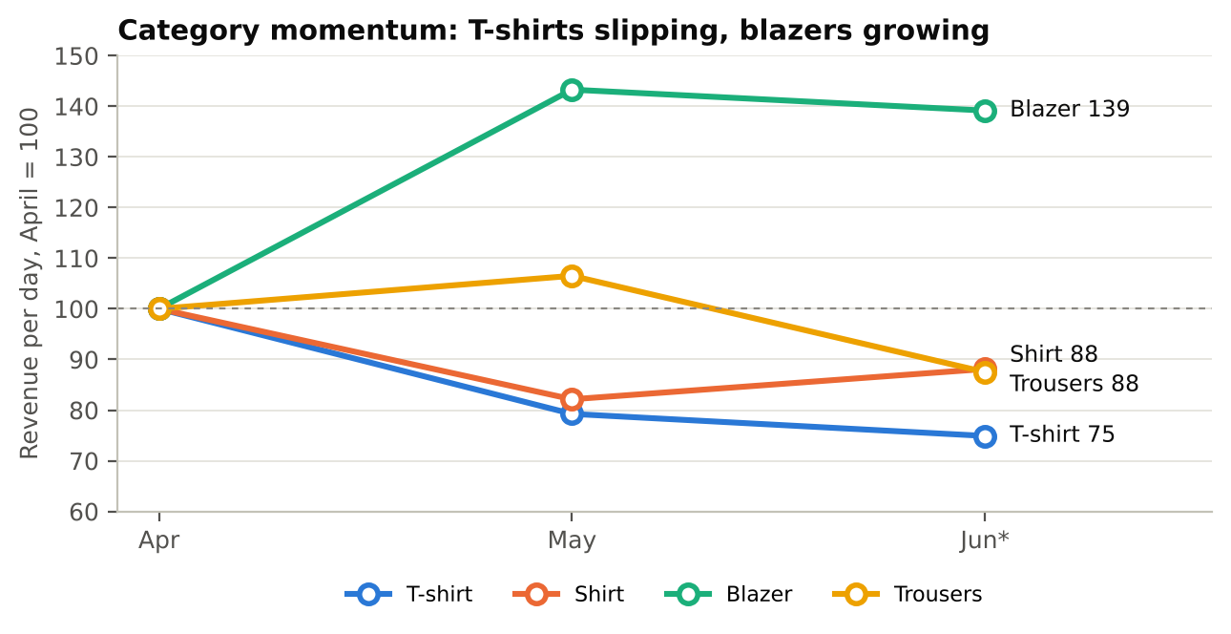
- T-shirts lost the most ground: -25% revenue per day, April to June (₹468K → ₹351K). That gap is worth about ₹3.5M a month and is almost all (97%) of the ₹3.6M-a-month fall in total run-rate.
- Blazers grew +39% and are the only growing category. Blazer is also the category with the highest recorded return rate (2.6%), so grow it with attention to fit and sizing.

Sizes and quantities
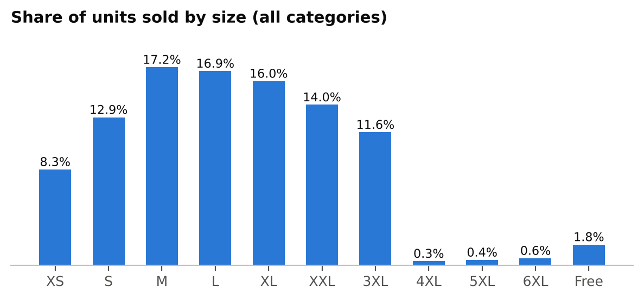
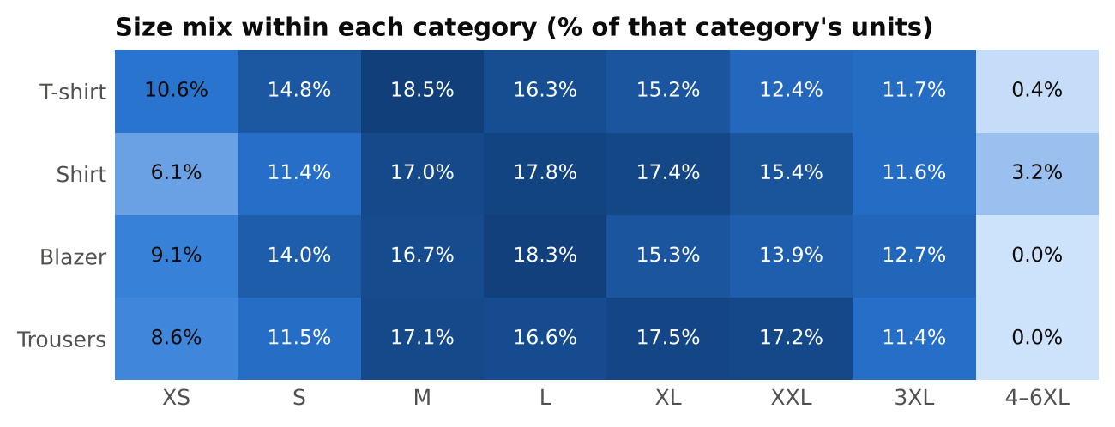
- M, L and XL are 50.1% of units; with S and XXL the five central sizes (S–XXL) make up about 77%. XXL and 3XL together add 26%, so the customer base skews to larger sizes.
- Extended sizes (4XL–6XL) are tiny overall (1.4% of units, ₹1.24M of sales) but they are a shirt phenomenon: 3.2% of shirt units against 0.4% of T-shirts and none for blazers or trousers.
- XS is a T-shirt size, not a shirt size: 10.6% of T-shirt units but only 6.1% of shirt units.
- Trousers skew larger (XL 17.5%, XXL 17.2%) while blazers peak at L (18.3%).

5. Fulfilment analysis
Method | Lines | Share | Net sales | Share | Avg. line | Cancel rate | Return rate
Amazon-fulfilled | 89,085 | 70% | ₹50.4M | 71% | ₹662 | 12.6% | not recorded
Merchant (Easy Ship) | 38,932 | 30% | ₹20.9M | 29% | ₹668 | 17.4% | 6.5%

Return rate = returned lines ÷ non-cancelled lines. Amazon-fulfilled returns do not appear in this extract.
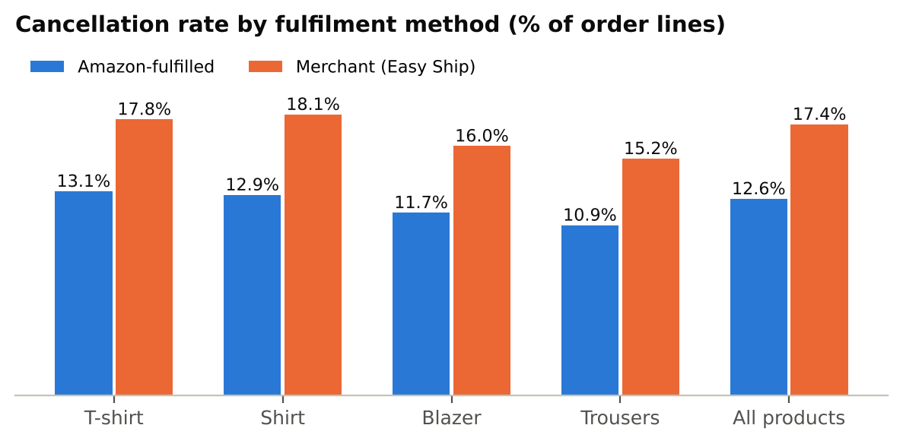
- The cancellation gap is consistent, which points to the process, not the product mix. Merchant orders cancel 4.8 points more often overall, and the gap holds in every category (T-shirt 4.6, Shirt 5.2, Blazer 4.3, Trousers 4.3 points) and every month (4.7–4.9 points).
- Value at stake: if Easy Ship cancelled at Amazon's rate, about 1,869 more lines would convert over the three months, roughly ₹1.25M of sales (1.8% of the total). This is an upper bound; some cancellations are customer-initiated and unavoidable.
- Merchant orders also carry the only recorded returns: 2,100 lines (6.5% of non-cancelled Merchant lines), worth ₹1.38M. Amazon-fulfilled returns are not in the extract, so do not read this as Amazon being return-free.
- Speed and method cannot be separated. 99% of Amazon-fulfilled lines ship Expedited and every Merchant line ships Standard, so the data cannot show whether faster shipping, rather than the fulfilment method itself, drives the lower cancellation rate.
- Operational flags at extract date: 6,799 Merchant lines (17%) were still “On the Way”, 519 were unshipped, and 933 lines overall were in a pending state. Without delivery dates, transit time cannot be judged, but the pending and unshipped lines should be reviewed for ageing.

6. Customer segmentation
There is no customer identifier in the extract, so customers are segmented by what they do within an order (basket size, value, buyer type) and where they are. The 100,600 non-cancelled orders with a recorded value fall into five behavioural segments.
Segment | Definition | Orders | Order share | Avg. order | Net sales | Revenue share
Core single-item | One item, ₹472–₹1,132 | 61,713 | 61.3% | ₹714 | ₹44.1M | 61.8%
Value single-item | One item, ≤ ₹471 (bottom 25%) | 25,792 | 25.6% | ₹390 | ₹10.1M | 14.1%
Premium single-item | One item, ≥ ₹1,133 (top 10%) | 6,568 | 6.5% | ₹1,287 | ₹8.5M | 11.9%
Multi-item buyers | More than one item or unit | 5,799 | 5.8% | ₹1,408 | ₹8.2M | 11.5%
B2B | Flagged business buyers | 728 | 0.7% | ₹765 | ₹0.6M | 0.8%

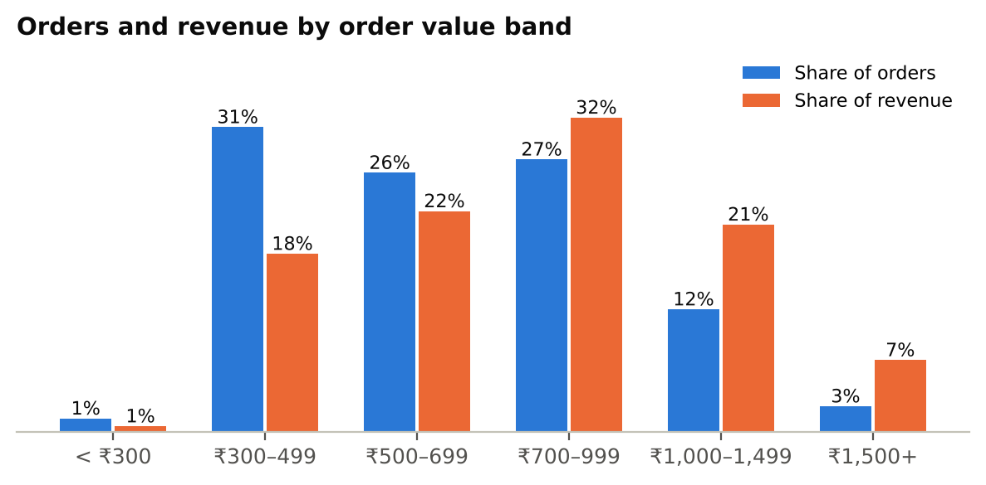
- A broad middle carries the business. Core single-item buyers are 61% of orders and 62% of revenue at about ₹714 per order.
- Low-value orders are common: orders under ₹500 are 32% of orders but only 18% of revenue; orders of ₹1,000+ are just 15% of orders yet 28% of revenue.
- Multi-item buyers are the most valuable and the rarest. They are 5.8% of orders with an average of ₹1,408. Every 1 percentage point of orders moved from single-item to multi-item would add about ₹0.75M over a comparable period (illustrative).
- B2B is negligible (728 orders, 0.7%) with only a slightly higher average (₹765); treat it as an opportunistic channel unless a dedicated bulk offer is planned.
- Location changes price, not basket behaviour. The average line value is ₹699 in the North versus ₹644 in the South (9% higher), while orders from the 13 largest cities and the rest of India look alike on average order value (₹706 vs ₹711) and multi-item share (5.8% vs 5.4%).

7. Geographical analysis
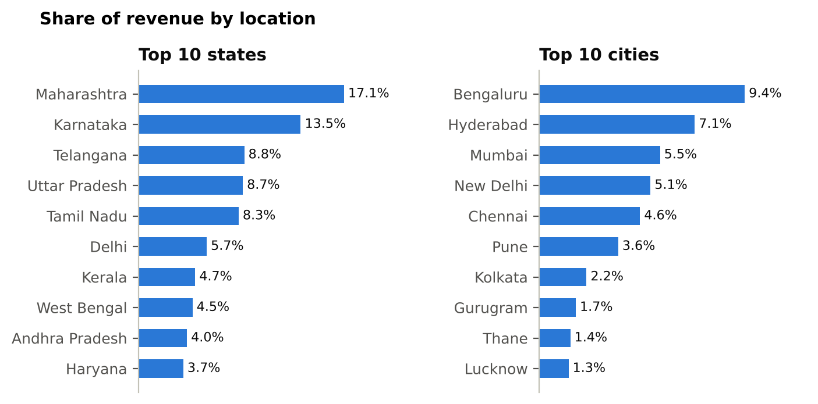
Region | Net sales | Share | Avg. line value | Cancel rate
South | ₹28.3M | 39.7% | ₹644 | 14.3%
North | ₹17.5M | 24.6% | ₹699 | 14.0%
West | ₹15.3M | 21.4% | ₹651 | 13.1%
East | ₹6.5M | 9.2% | ₹681 | 15.3%
Central | ₹2.0M | 2.7% | ₹686 | 14.7%
Northeast | ₹1.7M | 2.4% | ₹688 | 14.5%

Regions group states by geography (West: Maharashtra, Gujarat, Goa; North: Delhi, Haryana, Punjab, Uttar Pradesh, Rajasthan and others; South: Karnataka, Telangana, Tamil Nadu, Andhra Pradesh, Kerala; East; Central; Northeast).
State | Net sales | Share | Avg. line value | Cancel rate | Return rate*
Maharashtra | ₹12.2M | 17.1% | ₹649 | 13.2% | 1.4%
Karnataka | ₹9.6M | 13.5% | ₹655 | 12.9% | 1.4%
Telangana | ₹6.3M | 8.8% | ₹661 | 14.3% | 1.7%
Uttar Pradesh | ₹6.2M | 8.7% | ₹704 | 15.0% | 2.7%
Tamil Nadu | ₹5.9M | 8.3% | ₹615 | 13.7% | 1.6%
Delhi | ₹4.0M | 5.7% | ₹682 | 12.9% | 1.7%
Kerala | ₹3.3M | 4.7% | ₹634 | 17.6% | 1.5%
West Bengal | ₹3.2M | 4.5% | ₹647 | 14.7% | 2.4%
Andhra Pradesh | ₹2.9M | 4.0% | ₹646 | 16.2% | 2.2%
Haryana | ₹2.6M | 3.7% | ₹709 | 12.5% | 1.7%

*Recorded returns, Merchant-fulfilled only, as a share of non-cancelled lines.
- Concentration: the top 5 states hold 56% of sales and the top 10 hold 79% of 36 states/UTs served. Among 6,803 ship-to cities, the top 10 give 42%; Bengaluru alone gives 9.4%.
- South leads at 40%, then North (25%) and West (21%). East, Central and Northeast together are 14%.
- Cancellation hot-spots: Kerala (17.6%) is the biggest, ahead of Andhra Pradesh (16.2%) and Bihar (16.1%); Himachal Pradesh is higher still (18.6%) but on small volume. Kerala also has the lowest Amazon-fulfilment share of the top 15 states (65.8%), which fits the Easy Ship finding; Andhra Pradesh does not, so its cause is something else.
- Higher-ticket, smaller markets: Bihar, Rajasthan, Haryana, Odisha and Uttar Pradesh have average line values of about ₹704–₹739, above the big southern states (₹615–₹661). Bihar and Odisha also show the highest recorded return rates among the top 15 states.

8. Business insights and recommendations
Actions are ordered by expected impact. Sizes quoted are derived from gaps observed in this data; they are illustrations of scale, not forecasts.
# | Action | Evidence | What to do | Success measure
1 | Recover T-shirt demand | T-shirt revenue/day -25% Apr→Jun (≈₹3.5M/month); 50% of sales | Review T-shirt pricing vs. competitors, promotions and ad spend since April; check stock-outs in M/L/XL; test hero-SKU refresh | T-shirt revenue/day back to ≥ 90% of April
2 | Cut Easy Ship cancellations | Merchant cancels 17.4% vs 12.6%; ≈₹1.25M per quarter at stake | Move fast sellers (M/L/XL T-shirts and shirts) to Amazon fulfilment; audit stock sync and pick-up SLAs; capture cancel reasons | Merchant cancel rate ≤ 14% within a quarter
3 | Rebuild the size curve by category | M/L/XL = 50% of units; 4–6XL only matters for shirts | Buy per-category curves: add 4–6XL to shirts only, lighter XS on shirts, deeper XL/XXL on trousers, deeper L on blazers | Fewer size-driven stock-outs; lower aged stock in XS and 4–6XL
4 | Lift order value with bundles | 94% single-item; multi-item AOV ₹1,408 vs ₹665 | Shirt + trouser and blazer + shirt bundles; spend-threshold offer near ₹1,000; cross-sell on product pages | Multi-item share from 5.8% towards 8%
5 | Back blazers | Only growing category (+39%); ₹777 avg. line | Widen the blazer range, protect stock in L/XL/XXL, and fix fit information to hold returns down | Blazer share of sales above 14%
6 | Defend core metros, fix regional leaks | Top 6 cities = 35% of sales; Kerala/AP cancel 16–18% | Keep regional stock close to Bengaluru, Hyderabad, Mumbai, Delhi, Chennai, Pune; investigate Kerala and Andhra Pradesh delivery/cancel causes; review returns in Bihar and Odisha | State cancel rates within 2 pts of the national rate
7 | Rationalise the long tail | Perfume, wallets, socks, shoes, watches = 1.9% of sales | Run a time-boxed test or prune; free up working capital for core categories | Decision by next review
8 | Fix the data | No customer ID, SKU, cancel reason, delivery date; FBA returns missing | Add these fields to the export; track repeat-purchase rate, delivery time and return reasons | Next analysis can measure repeat rate and delivery speed

Suggested monitoring dashboard
- Weekly: revenue per day, orders per day, cancellation rate by fulfilment method, T-shirt vs blazer revenue index.
- Monthly: size-curve share by category, multi-item order share, order-value band mix, state and city revenue share, region cancel rates.
- Alert thresholds worth setting: cancellation rate above 15%, revenue per day more than 10% below the prior month, and any category share falling more than 2 points.

Appendix: definitions
- Net sales: sum of Amount for non-cancelled order lines, before deducting returns.
- Active order: an Order ID with at least one non-cancelled line. Average order value uses orders with a recorded value above ₹0.
- Cancel rate: cancelled lines ÷ all lines (after de-duplication). Return rate: lines with status Returned / Returning to Seller or Rejected by Buyer ÷ non-cancelled lines.
- Per-day rates: monthly totals divided by calendar days in the window (Apr 30, May 31, Jun 1–28 = 28).
- Largest cities: Bengaluru, Hyderabad, Mumbai, New Delhi, Chennai, Pune, Kolkata, Gurugram, Thane, Lucknow, Ahmedabad, Noida, Jaipur.

